Food Marketing Session 3: Handout

Example of a youth-led countermarketing campaign
Source: Big Issue, https://www.bigissue.com/news/activism/teenage-activists-deliver-wheelbarrows-of-mud-to-kelloggs-factory-to-protest-misleading-health-claims/

Teenage activists deliver wheelbarrows of mud to Kellogg's factory to protest 'misleading' health claims
They jokingly claimed their "müd" bars are high in fibre, low in fat, and a great source of minerals
GREG BARRADALE 29 Jun 2022

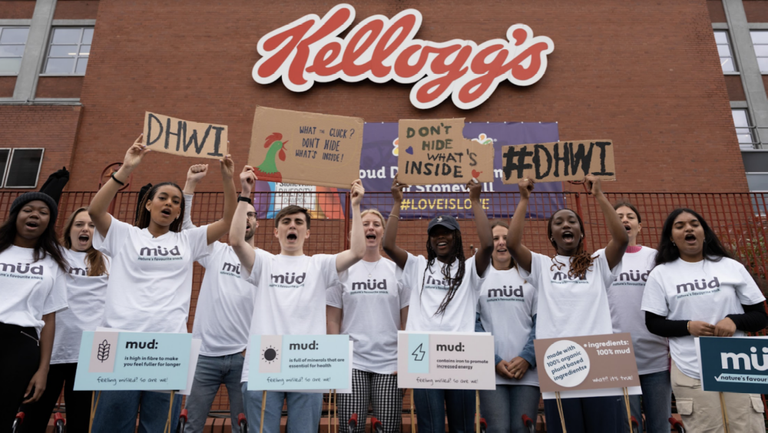
The protesters held signs as part of a 'Don't Hide What's Inside' campaign. Image: Bite Back 2030

High in fibre, low in fat, and a great source of minerals – a new health food has arrived at the Kellogg’s factory in Manchester. Mud.
Young activists from the group Bite Back 2030, founded by Jamie Oliver, have delivered a year’s supply of “müd” to the cereal company, in protest at what they call “misleading” health claims.
Taking aim at products like cereal bars and smoothies, which are perceived as healthy but often contain high levels of sugar, the protesters called on Kellogg’s to be more upfront with its packaging.

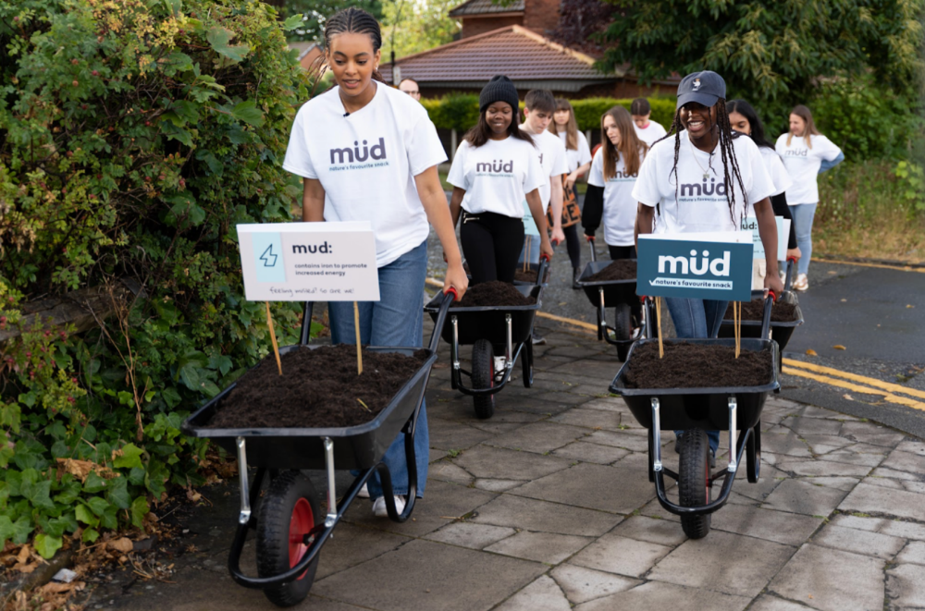
The protesters carried wheelbarrows full of mud. Image: Bite Back 2030

Barakat Omomayowa, a campaigner with Bite Back 2030 said: “It was ridiculously easy to copy big-brand tactics and develop a product that, based on health claims alone, people would want to buy.
“It might seem wacky, but these are the marketing tactics that young people are up against every day.”
The protesters arrived at the factory with wheelbarrows full of the new, 100 per cent mud snack bars.
Research published by Bite Back 2030 found that 8 in 10 young people are led to believe cereal bars are healthy, but 81 per cent would get a red traffic light label.

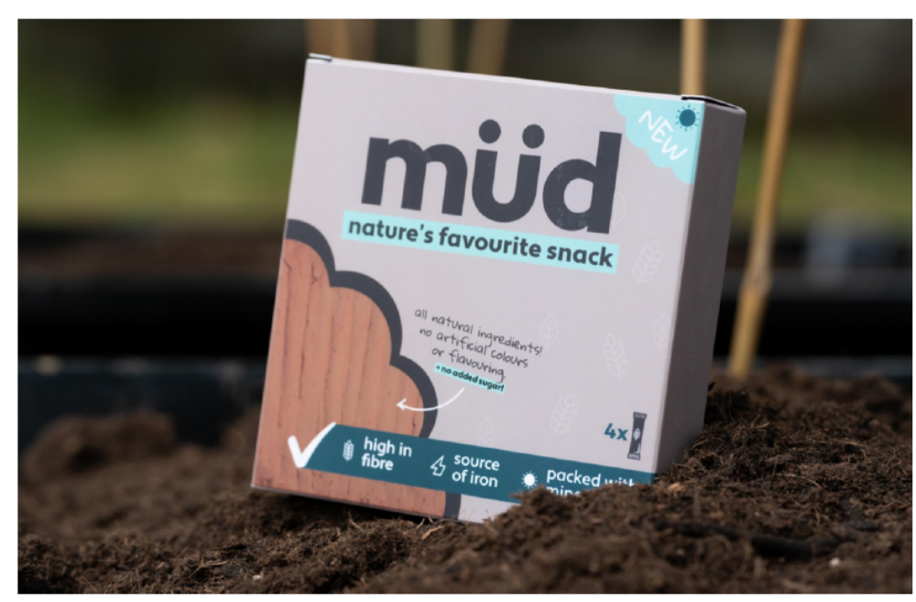
The packaging boasted of ‘all natural ingredients’ and ‘no artificial colours or flavouring’. Image: Bite Back 2030

For example, the report found that Kellogg’s Crunchy Nut Bites, which were marketed as having “added goodness” and “no artificial colours or flavours”, also had a third of your free sugars per 30g portion, and were rated amber for salt and saturates.
Strawberry Fruit Winders, marketed as an “on-the-go snack” were over a third sugar.
A Kellogg’s spokesperson said: “We are always really open about what’s in our food by including things like labelling so people can make their own mind up about whether they want to buy our products or not. All the claims we use on pack follow the rules set down in law. So, to claim we mislead people or somehow hide things is in itself misleading.”
Kellogg’s are not the only company who feature in the report for labelling high sugar products as healthy.
Nature Valley’s Crunchy cereal bars and Cadbury Brunch Bar are both listed in the research as being over a quarter sugar but with no traffic light labelling to inform consumers. A strawberry and banana smoothie from Innocent, meanwhile, delivers more than 80 per cent of the maximum recommended sugar intake.
Becky Odoi, who took part in the stunt, said: “This might give people a laugh, but we’re serious. The food system is rigged against our health and whilst it should be easy to eat healthily, it isn’t.
“Right now, the health of one in three 11 year olds is at risk from the food they eat, so we need the health secretary to step in and introduce clear, mandatory labelling policies that protect our health.”
They took aim at the government’s National Food Strategy, which was published earlier this month and branded “not a strategy” by its lead advisor.
Along with failing to widen eligibility for free school meals, the strategy also rejected proposals to introduce a sugar and salt tax.

