New Resource: Fruit Drink & Toddler Milk Videos from 1,000 Days and the UConn Rudd Center for Food Policy & Obesity

The UConn Rudd Center and 1,000 Days have released two new videos that dispel the marketing hype about fruit drinks and toddler milks, inform parents about why they are not recommended for young children, and encourage parents to “keep it simple, keep it real” by serving water and plain milk to their toddlers. This toolkit helps you share the videos with your audiences. The videos are available in English and Spanish.
- Fruit Drinks video
- Toddler Milks video

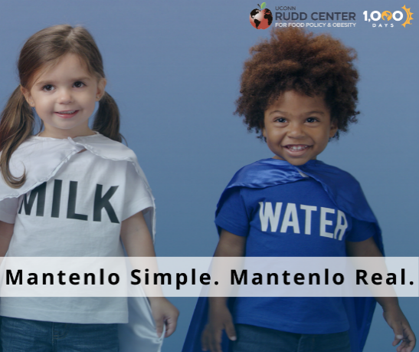
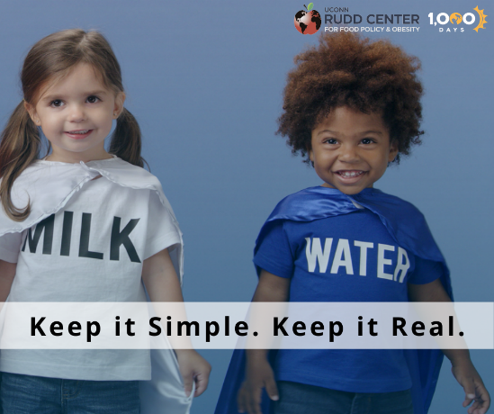

Sample Social Media Posts to Share
- Ever wonder about those toddler milks you see near infant formula at the grocery store?
Watch this video from @1000days and @UConnRuddCenter: https://cutt.ly/TlMtbk0
- ¿Te has preguntado acerca de las leches infantiles que ves cerca de las fórmulas en el supermercado? Mira este video de @1000days y @UConnRuddCenter: https://cutt.ly/alMtPO6

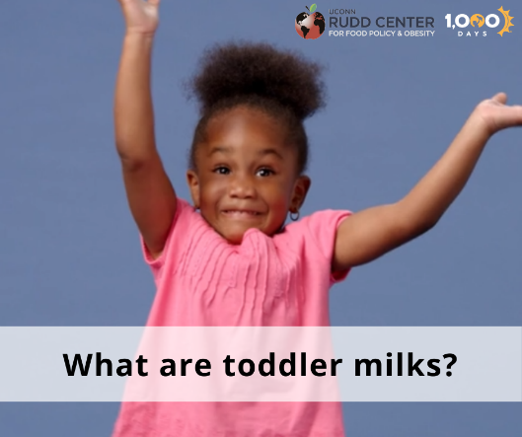

- Kids’ fruit drinks may seem healthy from the outside, but what’s inside may surprise you. Watch this video from @1000days @UConnRuddCenter: https://cutt.ly/AlMyqmD

- Las bebidas de frutas parecen saludables por fuera, pero lo que tienen dentro podría sorprenderte. Mira este video de @1000days y @UConnRuddCenter: https://cutt.ly/plMyvwy

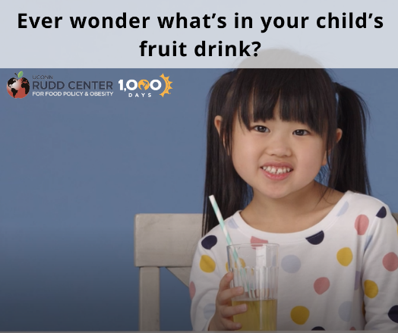

Sample Newsletter Blurb

The UConn Rudd Center and 1,000 Days have released two new videos for parents to help correct common misperceptions about the drinks they often serve their young children. Marketing of fruit drinks and toddler milks portrays these products as healthy drinks for toddlers, but child health experts do not recommend serving these sugary drinks to young children for many reasons. In less than 60 seconds, these videos dispel the marketing hype about fruit drinks and toddler milks and inform parents about their true ingredients and why experts do not recommend them. They encourage parents to “keep it simple, keep it real” by serving water and plain milk to their young children – the only drinks experts say toddlers need for a healthy diet. Check out the videos, available in English and Spanish, here: Fruit Drinks video; Toddler Milks video

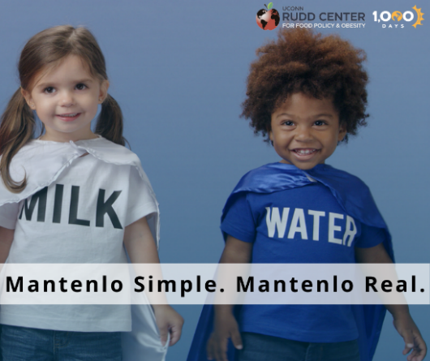

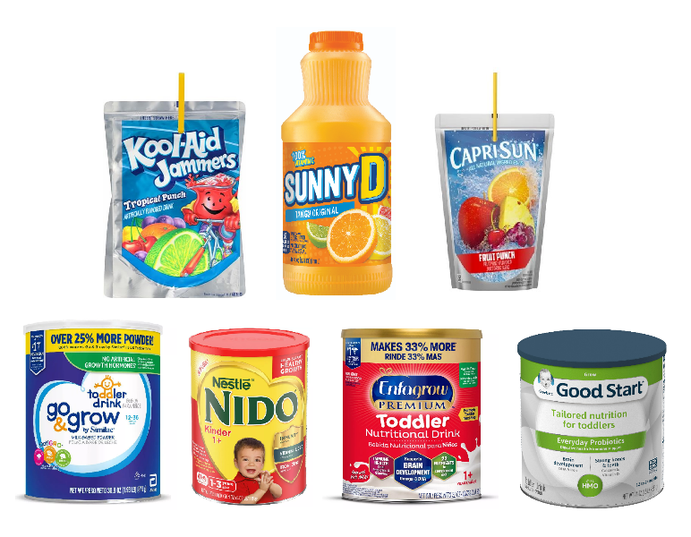
Blog Template
We’ve all been told not to judge a book by its cover, and the same applies when it comes to selecting drinks for your kids. Product labels highlight nutrition claims and mask ingredients such as added sugars and diet sweeteners, so it’s easy to see why many parents believe that children’s fruit drinks and toddler milks are healthy. However, child health experts, including the American Academy of Pediatrics, do not recommend serving these drinks to young children for many reasons.

First, both fruit drinks and toddler milks have added sugars. Toddler milks also have more sodium and less protein than plain milk, and they can cost four times as much. Fruit drinks have almost no juice and most have diet sweeteners in addition to added sugars. What’s more, research shows that providing sugary drinks to toddlers likely increases their sweet preferences and may reduce their acceptance of unsweetened beverages such as plain milk and water. According to experts, those are the only drinks toddlers need. That’s why 1,000 Days and the UConn Rudd Center have created new videos to counter common misperceptions about children’s fruit drinks and toddler milks.

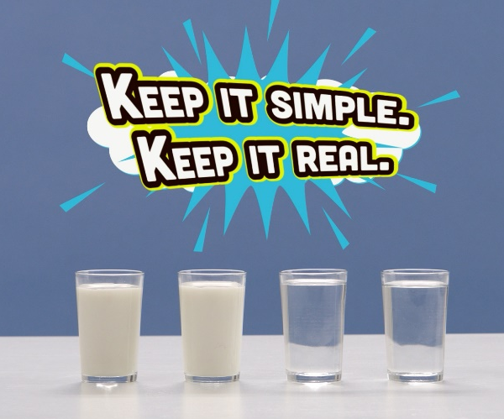
The 45-second videos dispel the marketing hype and shed light on what’s really in these drinks in an upbeat, easy-to-follow way. They encourage parents to “keep it simple, keep it real” by serving water and plain milk to their young children.

Nearly one-third of toddlers consume sugary drinks at age 1, rising to almost half of 2- to 4-year-olds (Source). Fruit drinks are the most common type of sugary drink served to young children. Toddler milks are aggressively marketed to parents of young children, and sales are growing rapidly. Reducing sugary drink consumption, especially toddler milks and fruit drinks, by young children is critical for a healthy start. Check out the videos, available in English and Spanish, here: Fruit Drinks video; Toddler Milks video

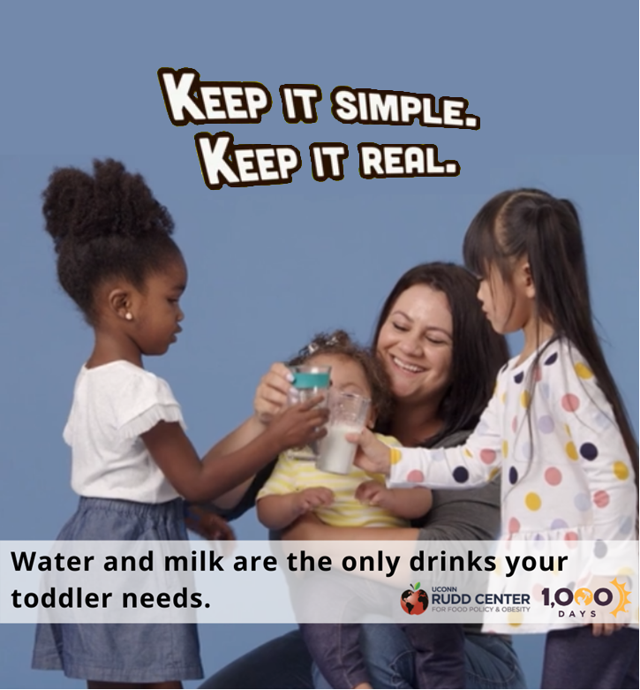

What a child eats and drinks during the early years has lifelong impacts.  That’s why 1,000 Days and the UConn Rudd Center created videos to cover what you really need to know about drinks for kids.  Learn more! | (YouTube Video Playlist)

